Yacht Club Billing and System of Record Database – Client Setup

By Scott N.

## Overview

The system has two components, a MySQL data store and MS Access based user interface. It is designed so that the data is stored in a shared MySQL database in the cloud. Either a dedicated cloud site like Azure or your web hosting server. A Microsoft Access front end is what the users work with and is distributed to the different roles of the yacht club like Secretary, Treasurer and Dock Master. Many people have MS Access via Office 365, or a free (no-form editing) version can be downloaded from Microsoft.

The Billing and System of Record database has 4 tasks for setting up.

## Get the Database from GitHub

1. Go to
2. Find file “BillingSystem.accdb”
3. Open the link
4. It will say it cannot display the file.
5. Above the message on the right is a drop down and select Download

## Get MySQL ODBC connector

Getting the free ODBC connector is a two step process. First you need to download MySQL’s Installer Tool and then Open the Installer and select the latest ODBC connector.

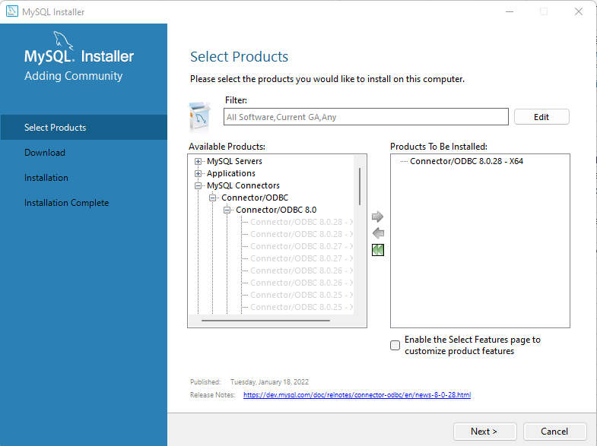

Say Next and then finish the Installation.

## Optional - Get MS Access (non-editing version)

## Make ODBC Connection

See your Web Master for access information

# Start Up

Trust the database